Article
Detection, Isolation, and Identification of Bacterial and Fungi Types From Butcher Shops in Basrah, Southern Iraq
Amaal Fadhil Ghanim¹, Alia .M. Abdullateef², Ahmid Hamid Dawood Alatbee³

1,2,3. Southern Technical University- Basrah Medical Technical Institute
*Correspondence : dr.amaal.f.g@stu.edu.iq¹, alia.abdullateef@stu.edu.iq², ahmed.dawood@stu.edu.iq³

Citation: Ghanim A. F., Abdullateef A. M., Alatbee A. H. D. Detection, Isolation, and Identification of Bacterial and Fungi Types From Butcher Shops in Basrah, Southern Iraq. American Journal Of Bioscience And Clinical Integrity 2026, 3(8), 33-39.
Received: 10th May 2026
Revised: 11th Jun 2026
Accepted: 24th Jul 2026
Published: 30th Aug 2026

Copyright: © 2026 by the authors. Submitted for open access publication under the terms and conditions of the Creative Commons Attribution (CC BY) license (https://creativecommons.org/licenses/by/4.0/)
Abstract: Background: retail butcher shops are a key element in the meat supply chain, and they can present serious public health threats when hygiene is not maintained properly. Raw meat is a nutritious environment that is easily colonized by bacteria and fungi, and can result in a widespread outbreak of food poisoning. Objectives: The objectives of the present study were to isolate, identify and characterize the bacterial and fungal species found in retail butcher shops of Basrah, southern Iraq and evaluating the environmental contamination and sanitary conditions of these shops.Methods: Aseptic laboratory culture of the samples was carried out at four retail outlets (AL-tanuma, AL-Madina, AL-jazirah and Al-zubair). Swabs were transferred onto Nutrient agar, Blood agar and non-autoclaved Xylose Lysine Deoxycholate (XLD) selective media and then incubated at 37°C for 24–48 hours. Isolation was performed and organisms were investigated using their colony morphology, Gram staining and diagnostic biochemical testing (indole, oxidase, catalase reactions). Conclusions: Four different types of microbial species were isolated from the butcher shops, namely Escherichia coli, Salmonella spp., Shigella spp., and the fungal yeast Candida albicans in the food of the butcher shop in Basrah city, Al Kuwait province, and the role of the butcher shop in spreading these pathogens to food. This study aims at determining the prevalence and identification of some foodborne pathogens such as Escherichia coli, Salmonella spp., and Candida albicans in the food of the butcher shop in Basrah city, Al Kuwait province, and the role of the butcher shop in spreading these pathogens to food.
Keywords: Butcher shop hygiene, Foodborne pathogens, Escherichia coli, Salmonella spp., Candida albicans, Food safety, Basrah

Introduction
Butcher shops play a critical role in the retail distribution of fresh meat to consumers; however, they also represent a potential source of microbial contamination if hygienic practices are inadequate. Meat and meat products contain an abundance of nutrients and hence provide an optimal habitat for the multiplication of various microbes, both pathogens and spoilage bacteria. Meat can get contaminated through a number of ways, such as during slaughter, processing, handling, storage and display, especially at smaller butcher shops where hygiene control practices may not be effectively implemented [1]. Foodborne pathogenic bacteria include Escherichia coli, Salmonella spp., Staphylococcus aureus, Listeria monocytogenes, and Campylobacter spp. These are known to cause significant risks for human health. The organisms mentioned above are among the most important etiological factors in the occurrence of foodborne illnesses throughout the world and can result in gastroenteritis, systematic diseases, as well as deaths in serious cases. According to recent statistics, foodborne disease is still a major health problem [2]. Isolation and identification of foodborne bacteria in butcher shops are vital for the evaluation of meat safety and hygiene practices. Microbiological techniques of bacterial isolation and identification, which include culturing, biochemical analysis and selective media, are still widely utilized due to their efficiency and economy. In the last few years, those techniques have also been augmented by modern molecular methods like PCR [3]. Several studies carried out in have reported high bacterial loads on meat surface, cutting instruments, display counters, and workers' hands, indicating that there is a need for surveillance not only of products but also contact surfaces [4]. There is growing concern about the presence of antibiotic-resistant bacteria in retail meat environment [5]. Objective of the study: this study aims to determine, isolate and identify different bacteria from butcher shops. Culture methods play an important role in identifying bacteria from meat and butcher shop environments. Meat samples, tools and surfaces are streaked on selective and differential media to count both general and pathogenic bacteria like aerobic mesophilic bacteria (overall load indicator), coliforms, Staphylococcus aureus, Escherichia coli, and Salmonella spp. Such techniques may also involve incubation, colony morphology, and biochemical test of the isolates [6]. Molds and yeasts can also be present on meat surfaces, instruments, cutting surfaces, and even air of butcher shops, causing food spoilage. Some of the commonly encountered molds and yeasts include Fungal genera in meat environment are Aspergillus, Penicillium, Fusarium, and Candida. Some strains of these fungi may produce mycotoxins that lead to adverse health effects in humans like kidney and liver damage as well as immunosuppression. [7] Fungal contamination can happen in meat production at various stages, especially in retail butcher shops where the quality of hygiene and environmental conditions affect microbial growth. Fungal growth can occur on meat carcasses, contact surfaces, personnel’s hands, and air that leads to the spread of fungal spores. While the main aim of food safety programs is the detection of bacterial contamination, fungal contamination can also suggest poor sanitation. Thus, fungal contamination in butcher shops should be monitored for food safety. The warm climate of Basrah city in southern Iraq may allow fungal growth. At the same time, there were few studies related to the contamination by fungi in butcher shops in this area. Thus, the goal of this research is the isolation and identification of fungi associated with the environment of butcher shops in Basrah city. [8]

Material And Methods
Material
Bunsen burner, Gas hose, Alcohol lamp spirit lamp, Petri dishes, Blood agar plates, Nutrient agar plates, Divided Petri dish, Test tube rack, Test tubes, Metal wire rack, Forceps, Marker pen, Incubator.
Methods
Meat samples were collected and transferred to the laboratory under aseptic conditions. Culture media (blood agar and nutrient agar& XLD) were prepared and poured into sterile Petri dishes. The samples were then inoculated onto the culture media using the streaking technique under sterile conditions with the use of a Bunsen burner or alcohol lamp to prevent contamination. These inoculated plates were then put into an incubator at a temperature of 37°C for 24-48 hours. After this process of incubation, the bacteria were observed for growth and their colony characteristics were studied.
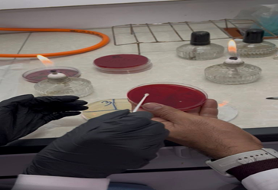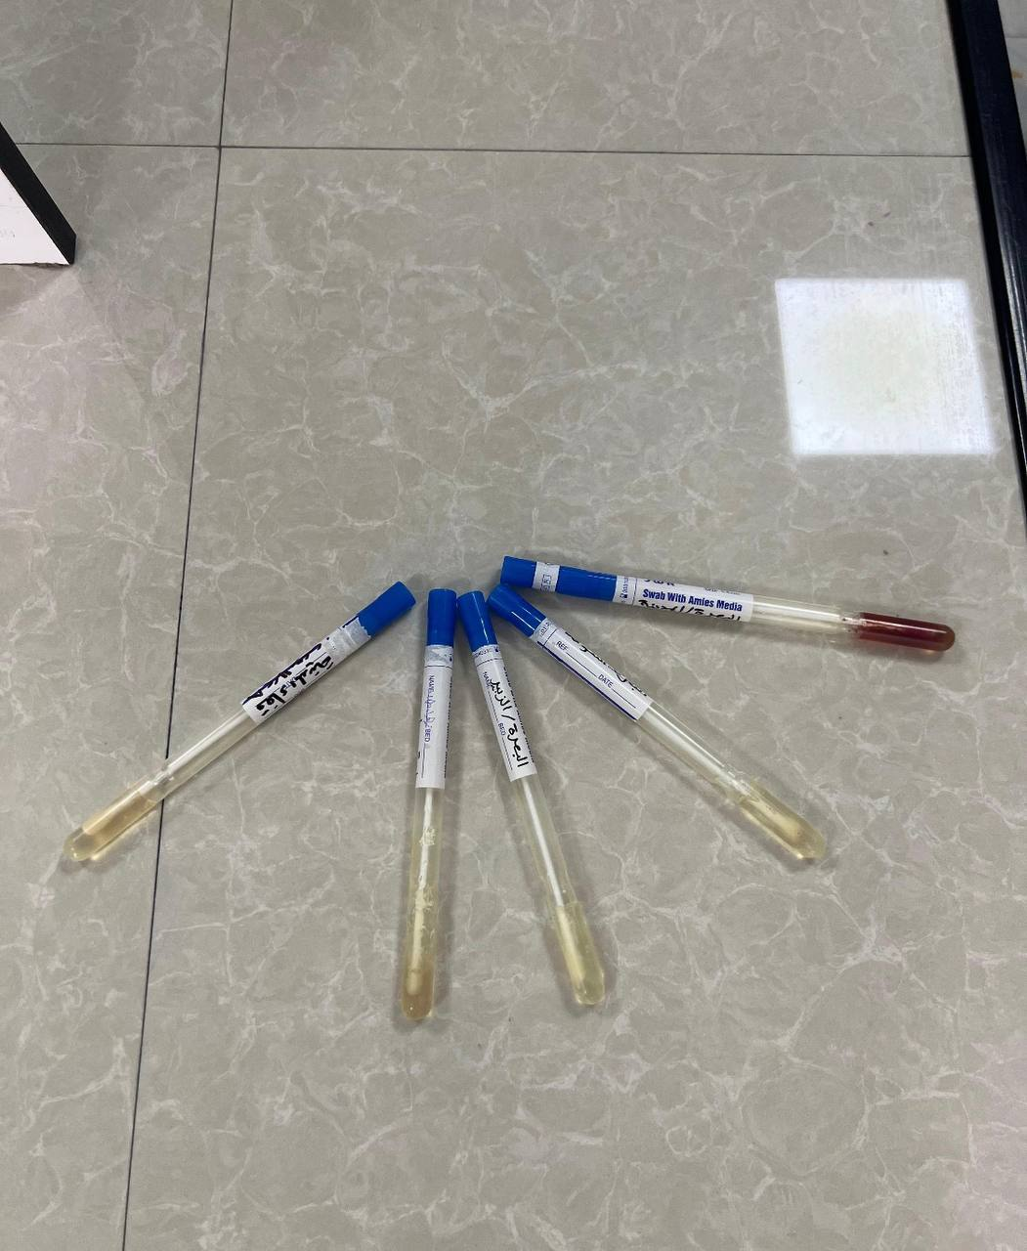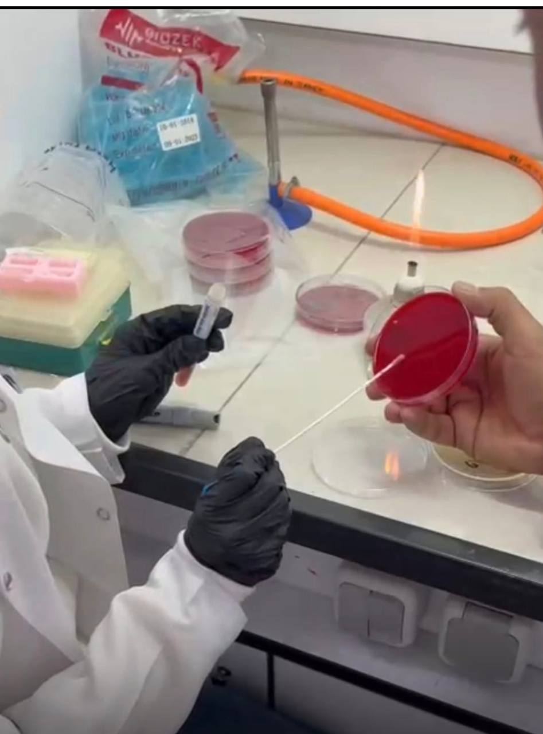
Figure 1. illustrates sample collection and media preparation.

Preparation XLD Steps
The preparation of XLD is somewhat different from the normal preparation process of TSA or LB media since it is very heat-sensitive. Excessive heating may result in precipitation of the deoxycholate and thus compromise the selectivity. To prepare the XLD, suspend by adding 56.68g of XLD agar to 1 liter of distilled water. (Note: This depends on the particular bottle.) Mix for 10 minutes until uniformly suspended.. Heat: Heat with frequent agitation and bring to a boil to dissolve the medium completely. Crucial Step: Do not autoclave. Excessive heat will destroy the nutrients and cause the indicators to break down. Cool: & transfer to a water bath at 45°C–50°C.
After inoculating the sample on culture media and incubating for 24 hours, bacterial growth was observed. Gram staining: A single bacterial colony was sterilely extracted from the sample using a loop. A small smear was prepared and heat-fixed on a sterile glass slide in the laboratory. After adding two drops of crystal violet stain, the mixture was left to stand for one minute. Iodine solution was added to wash the sample. The stain was quickly removed using acetone, ethanol, or a mixture of both. Safrane was used as an antistain. The slide was examined under 10x magnification.

Results And Discussion
Isolation and Identification of Microorganisms
The microbiological examination of samples collected from the selected butcher shops in Basrah revealed the presence of four microbial species or groups of particular food-safety relevance: Escherichia coli, Salmonella spp., Shigella spp., and the yeast Candida albicans. The isolation of both bacterial and fungal organisms demonstrates that contamination in retail butcher shops is not restricted to a single microbial group but may involve microorganisms originating from raw meat, handlers, equipment, contact surfaces, and the surrounding environment. The findings therefore directly address the primary objective of the study, which was to isolate and identify bacterial and fungal microorganisms associated with butcher shops and to assess their implications for sanitary conditions.
The detection of E. coli is particularly important because members of this species are commonly used as indicators of fecal or environmental contamination. Although not all E. coli strains are pathogenic, their presence in food-handling environments may indicate inadequate sanitation or contamination occurring during slaughtering, processing, transportation, handling, or retail display. Pathogenic strains can cause gastrointestinal disease and, depending on the strain, may produce serious clinical outcomes. The present finding is consistent with previous research showing that raw meat and butcher-shop environments can become contaminated through multiple routes, including contaminated carcasses, equipment, workers' hands, and inadequate cleaning procedures. Therefore, the isolation of E. coli in the investigated shops should be interpreted not simply as the presence of an individual organism but as a possible indicator of weaknesses in the overall hygiene chain.
The recovery of Salmonella spp. is also of considerable public-health significance. Salmonella is an important foodborne pathogen associated with contaminated meat and can survive in food-processing and retail environments when sanitation and temperature control are inadequate. Its detection suggests the possibility of contamination originating from infected animals, raw meat, contaminated equipment, or food handlers. The finding agrees with previous studies emphasizing the importance of retail meat as a potential vehicle for foodborne pathogens and the role of inadequate hygienic practices in facilitating their transmission. The presence of Salmonella therefore indicates that consumers may be exposed to a preventable microbiological hazard if contaminated meat is improperly stored, handled, or cooked.
The isolation of Shigella spp. provides another indication of possible fecal contamination and inadequate personal or environmental hygiene. Shigella is highly infectious, and relatively low numbers of organisms may be sufficient to cause disease. Consequently, its detection in a butcher-shop environment is particularly concerning. The finding may indicate contamination through human handling, contaminated water, surfaces, or other pathways associated with inadequate sanitation. Because Shigella is primarily associated with human fecal contamination, its detection also emphasizes the importance of strict hand hygiene among workers and the separation of food-handling activities from non-food activities.
The identification of Candida albicans demonstrates that fungal contamination should also be considered in assessments of butcher-shop hygiene. Yeasts and molds can occur on meat, equipment, processing surfaces, workers' hands, and in the surrounding environment. C. albicans is commonly associated with human microbiota, and therefore its recovery from a food-handling environment may indicate contamination associated with personnel or environmental contact. Although the detection of C. albicans does not by itself establish a foodborne disease risk equivalent to that of Salmonella or Shigella, it provides additional evidence that sanitation conditions require attention. More broadly, the simultaneous recovery of bacterial and fungal organisms suggests that microbial control in butcher shops should address both foodborne pathogens and environmental contamination.
Interpretation of the Morphological and Biochemical Findings
The morphological observations provided preliminary evidence for differentiating the isolated microorganisms. E. coli and Salmonella spp. were observed as rod-shaped organisms, whereas Shigella was recorded as a circular form in the presented results. However, bacterial morphology alone is insufficient for reliable species-level identification. For this reason, biochemical tests were used as additional diagnostic tools.
The biochemical results showed a positive indole reaction for E. coli, while Salmonella spp. were negative. The Shigella isolate showed a variable indole reaction. These observations are broadly consistent with the established biochemical characteristics of members of the Enterobacteriaceae family. The positive indole reaction of E. coli is associated with its ability to metabolize tryptophan through tryptophanase activity, whereas most Salmonella strains are indole-negative. The variable indole reaction reported for Shigella demonstrates why identification based on a single biochemical test should be approached cautiously.
The oxidase and catalase results provide additional differentiation between the isolates. However, the reported biochemical profile should be interpreted with caution because some of the combinations presented in Table 2 are not fully consistent with commonly accepted diagnostic profiles for E. coli, Salmonella, and Shigella. In particular, E. coli is generally oxidase-negative, while Salmonella and Shigella are also typically oxidase-negative; therefore, a positive oxidase result for E. coli may warrant verification of the test procedure and isolate identity. Similarly, catalase reactions should be interpreted alongside additional biochemical characteristics rather than independently. Contemporary diagnostic frameworks recommend using a combination of biochemical reactions and, where available, molecular confirmation for accurate identification of Enterobacteriaceae. Thus, the present results provide useful preliminary identification, but future studies should incorporate a broader biochemical panel or molecular techniques such as PCR to improve taxonomic certainty.

Table 1. bacterial& fungi isolated from the butcher shops
NO | Sample location | butcher shops | Microbes Isolated | shape
1- | AL-tanuma | 1- A | Escherichia Coli | Rod
2- | AL-Madina | 2- B | Salmonella spp | Rod
3- | AL-jazirah | 3- C | Shigella | circular
4- | Al-zubair | 4- D | Candida albicans | convex

Table 2. Biochemical Identification.
no | Biochemical test | E.coli | Salmonella spp | shigella
1- | Indole Test | + | _ | Variable
2- | Oxidase Test | + | _ | -
3- | Catalase Test | _ | + | +

Discussion
The Microbes Isolated in table shows the presence of four important microbial species—Escherichia coli, Salmonella spp., Shigella, and Candida albicans—recovered from butcher shop samples. This diversity reflects significant microbial contamination and indicates both bacterial and fungal presence in meat-handling environments. The isolation of Escherichia coli (rod-shaped) is particularly important because it is widely used as an indicator of fecal contamination. The presence of this organism implies bad hygiene practices in the slaughtering, processing, and handling of meat products. Some pathogenic strains of E. coli are the causative agents of gastrointestinal infections, hence the need for their identification as it is a health risk [9]. Like E. coli, Salmonella spp. (bacteria that are rod-shaped) are among the major causes of bacterial food infections globally. Their detection in butcher shops implies that there is cross-contamination of either from infected meat, equipment or handlers. Infections caused by Salmonella species result in severe gastroenteritis and sometimes systemic infections [10]. The presence of shigella (- shaped bacteria; wrongly mentioned in the above table) points to fecal contamination as well as poor hygiene. Shigella species are very infectious and only require a small amount of organisms to cause an infection [11]. In addition to bacteria, Candida albicans (convex yeast) can be detected as an indicator of fungi contamination. While C. albicans is a natural inhabitant of human flora, it suggests that there is contamination either by personnel or the environment, since it does not usually result in any disease [12]. All in all, the diverse spectrum of microorganisms found in this column clearly shows poor hygienic measures in butcher shops, which include improper cleaning of surfaces and environmental contamination [13].Such results highlight the necessity of proper enforcement of food safety measures like Hazard Analysis and Critical Control Points (HACCP), sanitation and worker training to minimize the dangers of microorganisms.[14] Biochemical characteristics in Table 2 illustrate the differential identification of Escherichia coli, Salmonella spp., and Shigella spp. through diagnostic test results like indole, oxidase and catalase tests. Such biochemical characteristics still play an important role in identifying microorganisms from the family Enterobacteriaceae.[15] The results of the indole test reveal that E. coli is positive, Salmonella spp is negative, and Shigella spp show variable reactions. This result can be explained by the presence of the enzyme tryptophanase in E. coli which changes tryptophan into indole, while most of the Salmonella do not possess the capability to form indole. Variable results observed in the Shigella are because of the different types of species present in Shigella that form indole in weak quantities.[16] Such variations in these results are an indicator of the complexity of classifying bacteria. In a laboratory experiment, for a "Variable" result, it is mandatory to conduct other tests (motility test or carbohydrate fermentation test) before identifying the species.[17]

Conclusion
This shows that the current guidelines for handling and processing are inadequate in ensuring that the consumers are protected from any danger. Isolation of Escherichia coli, Salmonella spp., Shigella, and Candida albicans in meat handling plants is a critical sign of unhygienic practices in the industry.
Storage: Store at 4°C (40°F) or cooler. Harmful bacteria such as Salmonella and E. coli can multiply rapidly between the "Danger Zone" (5°C to 60°C).
Cross-Contamination Prevention: Avoid transfer of bacteria from raw foods to clean foods, by keeping clean food and raw food surfaces physically apart and never using the hands in contact with cash with food-contact hands.
Dip knife blades often in a sterilizer (82°C).
Hand Hygiene: Wash hands for 20 seconds with warm, soapy water after cleaning up trash or handling money or changing tasks.
Equipment Sanitization: Wash and sanitize equipment after working with different species of meat, as well as after touching any non-food surface.
Single-Glove Protocol: If working alone, use gloved hand for meat and only the bare, clean hand for register, cash and cooler doors.

REFERENCES
[1] D. Grace, “Food safety in developing countries: Research gaps and opportunities,” Current Opinion in Food Science, vol. 49, Art. no. 100944, 2023.
[2] M. Haileselassie, H. Taddele, K. Adhana, and S. Kalayou, “Sources and contamination of meat by bacteria in butcher shops and abattoirs,” Journal of Food Safety, vol. 39, no. 4, Art. no. e12653, 2019.
[3] M. Lerasle, M. Federighi, and J. M. Cappelier, “Foodborne pathogens and meat safety: Current challenges,” Meat Science, vol. 167, Art. no. 108161, 2020.
[4] X. Zhang, Y. Li, J. Liu, and Y. Wang, “Microbiological quality and bacterial diversity of retail raw meat,” Food Control, vol. 125, Art. no. 107962, 2021.
[5] A. M. Ahmed, T. Shimamoto, and T. Shimamoto, “Molecular characterization of foodborne pathogens isolated from retail meat,” Food Microbiology, vol. 92, Art. no. 103556, 2020.
[6] D. A. L. Silva et al., “Hygiene and safety in the meat processing environment from butcher shops: Microbiological contamination and Listeria monocytogenes,” Journal of Food Protection, 2016.
[7] M. A. Rodrigues, P. Teiga-Teixeira, and A. Esteves, “Occurrence of moulds and yeasts in the slaughterhouse: The underestimated role of fungi in meat safety and occupational health,” Foods, 2025.
[8] L. A. Nasser, “Molecular identification of isolated fungi in canned meat products,” Saudi Journal of Biological Sciences, vol. 21, no. 3, pp. 291–295, 2014.
[9] J. B. Kaper, J. P. Nataro, and H. L. T. Mobley, “Pathogenic Escherichia coli,” Nature Reviews Microbiology, vol. 2, no. 2, pp. 123–140, 2004.
[10] S. K. Eng, P. Pusparajah, N. S. Ab Mutalib, H. L. Ser, K. G. Chan, and L. H. Lee, “Salmonella: A review on pathogenesis, epidemiology and antibiotic resistance,” Frontiers in Life Science, vol. 8, no. 3, pp. 284–293, 2015.
[11] K. L. Kotloff, M. S. Riddle, J. A. Platts-Mills, P. Pavlinac, and A. K. M. Zaidi, “Shigellosis,” The Lancet, vol. 391, no. 10122, pp. 801–812, 2018.
[12] R. A. Calderone and C. J. Clancy, Candida and Candidiasis, 2nd ed. Washington, DC, USA: ASM Press, 2012.
[13] J. F. MacFaddin, Biochemical Tests for Identification of Medical Bacteria, 3rd ed. Philadelphia, PA, USA: Lippincott Williams & Wilkins, 2000.
[14] M. A. Rodrigues, P. Teiga-Teixeira, and A. Esteves, “Moulds and mycotoxins in the meat production chain from slaughterhouse to market: A scoping review on Aspergillus and Penicillium isolation,” Foods, vol. 15, no. 4, Art. no. 630, 2026.
[15] F. B. Halimeh, R. Rafei, M. Osman, I. I. Kassem, S. M. Diene, F. Dabboussi, et al., “Current diagnostic frameworks and biochemical identification of Enterobacteriaceae in clinical and food microbiology,” Frontiers in Microbiology, vol. 14, Art. no. 1182901, 2023.
[16] Y. Zhang, X. Chen, L. Wang, and Y. Liu, “Metabolic and enzymatic characterization of tryptophanase and indole production across Enterobacteriaceae genera,” Research in Microbiology, vol. 175, no. 3, Art. no. 104120, 2024.
[17] A. Martinez-Perez and O. G. Gomez-Duarte, “Phenotypic variation and secondary biochemical testing for species-level differentiation of Shigella and Escherichia strains,” Journal of Clinical Microbiology, vol. 61, no. 5, Art. no. e00412-23, 2023.

