Article
Isolation and Identification of Enterococcus faecalis and Enterococcus lactis from Human Clinical Specimens

Israa Omar Humaidan¹, Aws Ibrahim Sulaiman^{*2}
1. University of Mosul, College of Science, Department of Biology, Mosul, Iraq
2. University of Mosul, College of Science, Department of Biology, Mosul, Iraq., Assistant Professor, Doctor, Pathogenic Bacteriology
*Correspondence: awssbio61@uomosul.edu.iq
Citation: Humaidan, I. O., Sulaiman, A. I. Isolation and Identification of Enterococcus faecalis and Enterococcus lactis from Human Clinical Specimens. American Journal of Biology and Natural Sciences 2026, 3(7), 92-99.
Received: 05th May 2026
Revised: 25th May 2026
Accepted: 30th Jun 2026
Published: 20th Jul 2026

Copyright: © 2026 by the authors. Submitted for open access publication under the terms and conditions of the Creative Commons Attribution (CC BY) license (https://creativecommons.org/licenses/by/4.0/)
Abstract: E. faecalis and E. lactis are opportunistic Gram-positive pathogens associated with soft tissue infections and are characterized by multidrug resistance and virulence potential. The aim of this study was to evaluate antimicrobial resistance patterns and to detect selected virulence genes in E. faecalis and E. lactis isolated from soft tissue infections. Two hundred and ten clinical specimens (biopsies, aspirates, and swabs) were collected and cultured on MacConkey, blood, chocolate, and brain heart infusion agars under aerobic and anaerobic conditions. Identification was performed by conventional methods, the VITEK2 system, 16S rRNA gene sequencing, and PCR detection of agg, esp, and ace genes. A total of 98 bacterial isolates were collected. VITEK2 identified two isolates as E. faecalis and two isolates as E. lactis, but 16S rRNA sequencing confirmed one strain per species. Genes (agg and esp) were present; ace was absent. All isolates that were confirmed were resistant to the antibiotics tested. Soft tissue infections harbor multidrug-resistant E. faecalis and E. lactis possessing key virulence genes, underscoring their clinical importance and the need for continued surveillance and infection prevention.
Keywords: Enterococcus faecalis, Enterococcus lactis, Soft Tissue Infections, Antimicrobial Resistance, Virulence Genes, 16S rRNA
Introduction
Enterococci are Gram-positive bacteria identified in 1899 as natural inhabitants of the human intestinal microbiota. These organisms had been taxonomically classified for many decades in the genus Streptococcus, specifically as serogroup D streptococci. Streptococcus faecalis is described in 1906 following its isolation from a clinical case of endocarditis. Streptococcus lactis is described in 1919. Major taxonomic differences among serogroup D streptococci have been identified with the advent of biochemical characterization techniques and molecular approaches, including DNA–rRNA homology studies and 16S rRNA gene sequencing. Based on these findings, they were reclassified into a separate genus Enterococcus, in 1984. The genus currently includes more than 50 recognized species, including Enterococcus faecalis and Enterococcus lactis, which are regarded as clinically important due to their frequent association with human infections and their increasing importance in medical microbiology [1], [2].
E. faecalis and E. lactis are clinically important opportunistic pathogens, particularly in hospitals. E. faecalis is the principal cause of enterococcal infections, accounting for approximately 80% of human cases, and is most frequently implicated in urinary tract infections, wound infections, bacteremia, and endocarditis [3], [4], [5].
In contrast, E. lactis is increasingly recognized for its capacity to adapt to healthcare environments, driven by resistance to antibiotics and environmental pressures. Genomic studies have identified two distinct clades, including hospital-adapted lineages closely linked to nosocomial outbreaks and opportunistic infections [2].
Due to the presence of virulence factors, antimicrobial resistance genes, and biofilm-forming ability, both species possess high pathogenic potential, which contributes to their persistence and clinical impact, and therefore pose a growing public health concern [6], [7], [8].
agg is one of the genes encoding an important virulence factor, the aggregation substance (AS), a plasmid-encoded adhesin regulated by pheromone signaling. AS is conducive to intimate contact between donor and recipient bacterial cells so that plasmids can be transferred successfully. AS is on the surface of the donor cell, but there must be a complementary binding substance on the recipient cell, encoded chromosomally, for the interaction to be successful [3].
The esp gene encodes the enterococcal surface protein (Esp), a protein that plays a role in bacterial adhesion to host and abiotic surfaces. The protein is involved in the formation of a biofilm that increases the persistence of bacteria in biopolymeric matrices [9].
ace is a virulence determinant of enterococci on their surface; the bacteria have a protein that helps them to adhere to several host components, including type IV collagen in the human body, type I bovine and rat collagen, murine laminin, and human dentin. In vivo, increased Ace expression has been demonstrated in the presence of serum and constituents of the extracellular matrix [10].

Materials and Methods
Ethics Statement
Ethical permission was granted to undertake this study by the Ministry of Health and Environment in Ninawa Health Department with approval number (272) on 1/10/2025.
Sample Collection
Two hundred and ten samples from surgical biopsies, aspirates, and swabs from different clinical sources were received. Samples were collected from Al-Salam Teaching Hospital, Al-Jumhouri General Hospital, and Ibn Sina Hospital of Mosul City during the period from 1/10/2025 to 1/2/2026. Samples of the three categories of the specimens were divided into equal parts to make 70 biopsies, 70 aspirates, and 70 swabs. All the samples were cultured on MacConkey, blood agar, chocolate agar, and brain heart infusion agar. Biopsy samples and anaerobic aspirates were kept in an anaerobic jar in the incubator.
Diagnostic Tests
The samples were incubated and then subjected to a series of morphological tests (Gram stain, catalase, oxidase, carbohydrate fermentation, morphology on different media). Identification of bacterial isolates was done by the VITEK2 automatic identification system on 24 hr old pure isolates. Colonies were reactive in sterile 0.45% sodium chloride solution, and turbidity was determined using a Densichek using the McFarland standard. Suspension was loaded into VITEK 2 cards with biochemical tests, and sample data were typed into the computer attached to it. The test included automated incubation, reading and interpretation to give a profile of the bacteria being tested.
Antibiotic Sensitivity Test (AST)
Antimicrobial susceptibility testing of bacterial isolates obtained from soft tissue infections was performed using the VITEK 2 Compact system (Bio analyse, Turkey). Manual susceptibility testing was additionally carried out to confirm the results and to include antibiotics commonly used in clinical practice.
Molecular Identification
Polymerase chain reaction (PCR) with the entire 16S rRNA gene was performed using the following reaction mixes (Go-Taq G2 Green Master Mix, Promega, USA): 16S rRNA 27F primer (AGAGTGATCMTGGCTCAG), 1522R primer (AAGGAGGTGATCCARCCGCA). The 16S rRNA gene study was determined by sending the products of the PCR reaction of the predetermined genes with the primers of the resulting package at Psomagene sequencing company (USA). The sequences of the genes were blasted against the sequences of the genes deposited in the National Centre for Biotechnology Information (NCBI). Then, the presence of the agg, esp, and ace genes was investigated in Enterococcus faecalis and Enterococcus lactis isolates.

Table 1. Thermal Programs Used to Investigate Genes Using PCR
Genes | Initial denaturation | Denaturation | Annealing | Extension | N Cycles | Final extension (Min/°C) | Reference
Agg | 94 °C / 5 min | 94 °C 40 sec | 50–68 °C 60 sec | 72 °C 60 sec | 30 | 72 °C / 7 min | [11]
Esp
Ace

Results
Distribution of Bacterial Isolates
Based on the phenotypic diagnosis and using the VITEK2 system, we obtained 98 bacterial growth samples from 210 clinical samples taken from patients suffering from soft tissue infections (abscesses, boils, surgical wounds, burns, diabetic foot ulcers), divided into swabs, aspirates, and biopsies as in Table 2.

Table 2. Distribution of bacterial isolates according to sample type.
Bacterial Isolates | Swabs | Aspirates | Biopsies
Staphylococcus aureus | 13 | 4 | 3
Coagulase Negative Staphylococci | 7 | 3 | 1
Streptococcus pyogenes | 5 | 3 | 2
Streptococcus agalactiae | 3 | 1 | 0
Enterococcus | 3 | 0 | 1
Clostridium spp. | 0 | 2 | 5
Proteus spp. | 5 | 2 | 3
Klebsiella spp. | 5 | 2 | 1
Pseudomonas spp. | 4 | 2 | 2
Escherichia coli | 3 | 1 | 0
Aeromonas spp. | 2 | 0 | 0
Bacteroides spp. | 0 | 4 | 5
Fusobacterium spp. | 0 | 2 | 0
Total | 50 | 25 | 23

Cultural Examination
The results of cultural examination of bacterial colonies showed bacterial colonies of Enterococcus spp. on blood agar presented small to medium, circular, smooth, greyish white colonies, showing mainly non-hemolytic (γ-hemolysis) activity with occasional weak α-hemolysis; on brain heart infusion agar, the isolates showed good growth with smooth, circular, slightly moist colonies that appeared creamy white to pale grey (Figure 1).
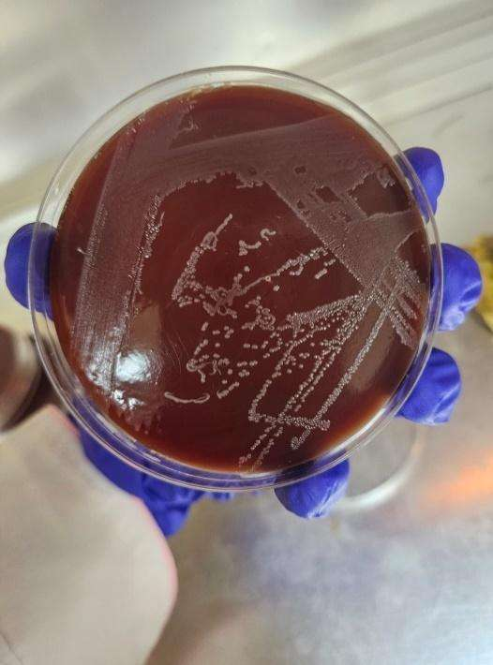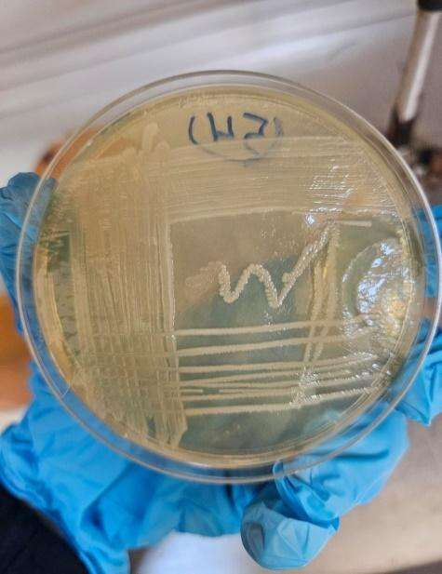
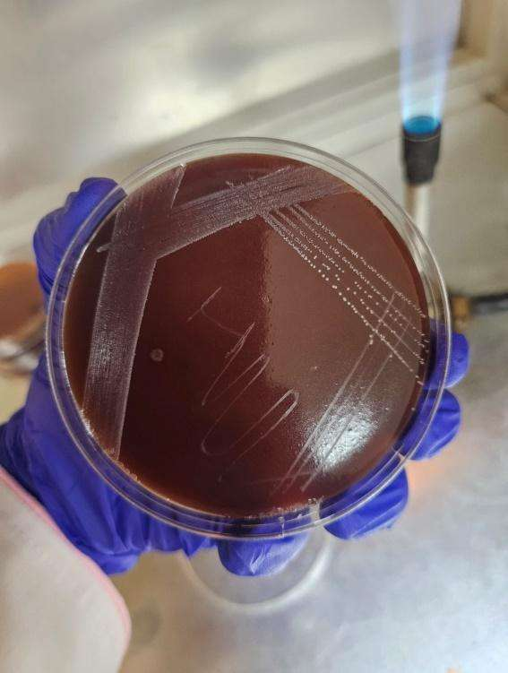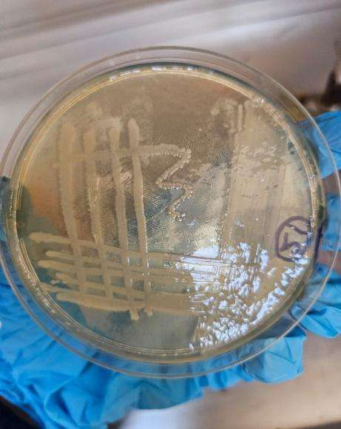
Figure 1. Appearance of A: Enterococcus faecalis, B: Enterococcus lactis on different agar.

Microscopic Examination
The E. faecalis and E. lactis are Gram-positive cocci bacteria, as shown in Figure 2.
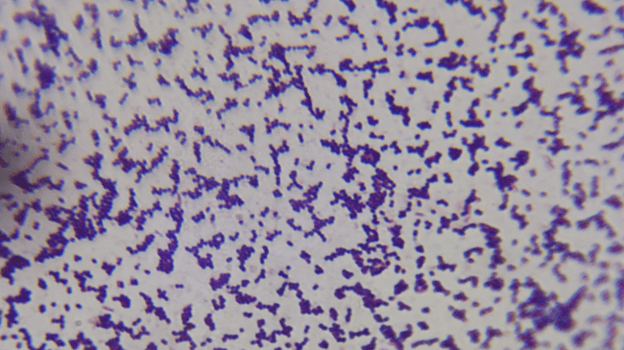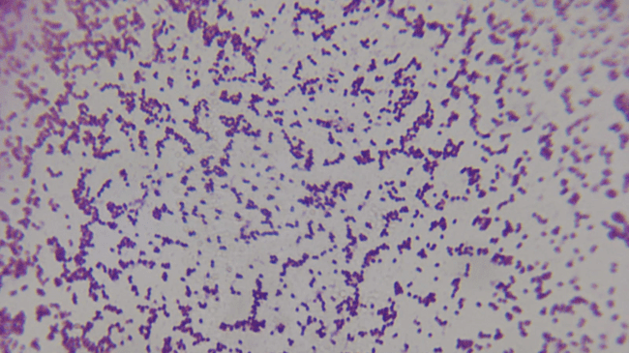
Figure 2. Microscopic examination for A: Enterococcus faecalis, B: Enterococcus lactis.
Antimicrobial Susceptibility
The antimicrobial susceptibility profile of Enterococcus faecalis and Enterococcus lactis isolates demonstrated resistance to ampicillin, clarithromycin, vancomycin, linezolid, tobramycin, erythromycin, levofloxacin, clindamycin, doxycycline and imipenem (Figure 3).
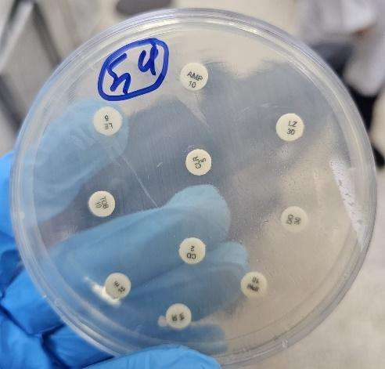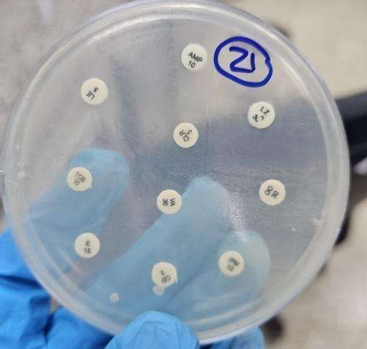
Figure 3. Disk diffusion showing the antibiotic resistance pattern of E. faecalis (54) and E. lactis (21).

Detection of agg, esp and ace Genes
Molecular analysis by PCR showed that the isolates of E. faecalis and E. lactis were positive for the virulence genes agg and esp and negative for the ace gene. The results of the present study showed the presence of agg and esp genes in isolates of both species (Figure 4).
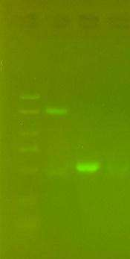
Figure 4. Gel electrophoresis of Enterococcus faecalis and Enterococcus lactis. L: ladder 5000 bp on 1% agarose. 1: agg (1553), 2: esp (510), 3: ace.

Discussion
E. faecalis and E. lactis were resistant to all the antibiotics used in the present study. Enterococci are especially proficient at acquiring antibiotic resistance through mobile genetic elements (MGEs) such as plasmids and transposons [12]. Hence, E. faecalis and E. lactis are often multi-drug resistant, including to clinically relevant antibiotics such as ampicillin and vancomycin [13]. Consequently, the World Health Organization (WHO) has designated VRE as a high-priority pathogen [14]. Vancomycin resistance is mainly the result of the vanA gene, which is part of the vanA operon and is often located on transposons, like Tn1546 [15].
Regarding the virulence determinants, the results of the present study showed the presence of agg and esp genes in isolates of both species. However, variability across studies has been well documented. For example, some authors reported a higher frequency of esp in E. lactis isolates than in E. faecalis ones, indicating species- and strain-dependent differences in the distribution of virulence genes [16].
In addition, Ace, described as a common adhesin in previous studies, particularly in invasive isolates, was not detected in any of the isolates analyzed in the present study. Such absence has also been reported elsewhere and may be due to geographic variation, differences in clinical origin, or the genetic diversity of circulating strains. Overall, these findings highlight the heterogeneous distribution of virulence determinants among Enterococcus spp. and their possible variability according to the local epidemiological condition. The presence of the agg (aggregation substance) gene suggests enhanced ability of the isolates to adhere to host cells and to induce bacterial aggregation, which promotes colonization and contributes to the transfer of virulence determinants. This gene has also been strongly linked to biofilm formation, thus enhancing the persistence of enterococci in clinical environments and their resistance to host immune responses [3].
Likewise, the presence of the esp (enterococcal surface protein) gene indicates the ability of these isolates to adhere to epithelial surfaces and medical devices. The esp gene is important for biofilm formation and is often associated with an increased pathogenicity and chronicity of enterococcal infections, especially those acquired in hospitals [9].
However, the absence of the ace (adhesion to collagen of Enterococcus) gene indicates that collagen-binding is not a primary adherence mechanism in the isolates studied. This suggests that other adhesion-related virulence factors such as agg and esp could compensate for the loss of ace, indicating the diversity of pathogenic strategies used by Enterococcus species. In general, these results suggest that E. faecalis and E. lactis possess important virulence-related genes that might be important for their pathogenic potential, even without some adhesion factors.

Conclusion
This study shows the presence of multidrug-resistant E. faecalis and E. lactis in soft tissue infections and emphasizes their clinical significance as emerging opportunistic pathogens. The combination of the presence of important virulence genes (agg and esp) and the absence of the ace gene indicates a unique virulence profile that may be involved in colonization and persistence in infected tissues. Furthermore, the complete resistance of the confirmed isolates to all antibiotics tested underlines the serious therapeutic problems raised by these organisms. The findings underscore the importance of ongoing epidemiological surveillance, effective infection control policies, and judicious use of antimicrobial agents to prevent the spread of resistant enterococcal isolates in clinical settings.

REFERENCES
[1] Y. B. Kim, K. W. Seo, J. B. Shim, S. hyun Son, E. B. Noh, and Y. J. Lee, “Molecular characterization of antimicrobial-resistant Enterococcus faecalis and Enterococcus faecium isolated from layer parent stock,” Poultry Science, vol. 98, no. 11, pp. 5892–5899, 2019, doi: 10.3382/ps/pez288.
[2] X. Zhou, R. J. Willems, A. W. Friedrich, J. W. Rossen, and E. Bathoorn, “Enterococcus faecium: from microbiological insights to practical recommendations for infection control and diagnostics,” Antimicrobial Resistance and Infection Control, vol. 9, no. 1, Art. no. 130, 2020, doi: 10.1186/s13756-020-00770-1.
[3] M. S. Attia and I. H. Al-Azawi, “The molecular identification of agg and hyl genes of Enterococcus faecalis isolated from different clinical samples,” Al-Qadisiah Medical Journal, vol. 19, no. 2, 2023.
[4] A. A. Shah, S. Khursheed, A. Rashid, and A. Gupta, “Isolation, identification, speciation, and antibiogram of Enterococcus species by conventional methods and assessment of the prevalence of vanA genotype among VRE,” Journal of Medical and Pharmaceutical Allied Sciences, vol. 11, no. 4, pp. 5037–5044, 2022.
[5] R. T. Ayanto, “Plasmid PCF10-mediated Enterococcus faecalis heterogenous tower-like biofilm structures influence biological properties of the biofilms,” Ph.D. dissertation, Temple University, Philadelphia, PA, USA, 2021.
[6] M. Shahveh, E. Tajbakhsh, H. Momtaz, and R. Ranjbar, “Molecular characterization of Enterococcus faecalis and Enterococcus faecium isolated from a meat source in Shahrekord local markets, Iran,” Archives of Razi Institute, vol. 78, no. 4, p. 1387, 2023, doi: 10.32592/ARI.2023.78.4.1387.
[7] O. M. Alzahrani, M. Fayez, A. S. Alswat, M. Alkafafy, S. F. Mahmoud, T. Al-Marri, A. Almuslem, H. Ashfaq, and S. Yusuf, “Antimicrobial resistance, biofilm formation, and virulence genes in Enterococcus species from small backyard chicken flocks,” Antibiotics, vol. 11, no. 3, Art. no. 380, 2022, doi: 10.3390/antibiotics11030380.
[8] F. Hasanpour, Z. Neyestani, M. Arzanlou, E. Moradi-Asl, A. Sahebkar, and F. Khademi, “Vancomycin-resistant enterococci in Iran: A systematic review and meta-analysis of non-clinical studies,” Gene Reports, vol. 24, Art. no. 101265, 2021, doi: 10.1016/j.genrep.2021.101265.
[9] O. N. Chuang-Smith, C. L. Wells, M. J. Henry-Stanley, and G. M. Dunny, “Acceleration of Enterococcus faecalis biofilm formation by aggregation substance expression in an ex vivo model of cardiac valve colonization,” PLoS One, vol. 5, no. 12, Art. no. e15798, 2010.
[10] M. E. Łysakowska, A. Denys, and M. Sienkiewicz, “Frequency of ace, epa and elrA genes in clinical and environmental strains of Enterococcus faecalis,” Indian Journal of Microbiology, vol. 52, no. 4, pp. 612–616, 2012, doi: 10.1007/s12088-012-0285-8.
[11] T. Strateva, D. Atanasova, E. Savov, G. Petrova, and I. Mitov, “Incidence of virulence determinants in clinical Enterococcus faecalis and Enterococcus faecium isolates collected in Bulgaria,” Brazilian Journal of Infectious Diseases, vol. 20, no. 2, pp. 127–133, 2016, doi: 10.1016/j.bjid.2015.11.011.
[12] C. N. Johnson, E. K. Sheriff, B. A. Duerkop, and A. Chatterjee, “Let me upgrade you: Impact of mobile genetic elements on enterococcal adaptation and evolution,” Journal of Bacteriology, vol. 203, no. 21, pp. 10–1128, 2021, doi: 10.1128/jb.00177-21.
[13] S. Bertagnolio, Z. Dobreva, C. M. Centner, I. D. Olaru, D. Donà, S. Burzo, and A. Kotwani, “WHO global research priorities for antimicrobial resistance in human health,” The Lancet Microbe, vol. 5, no. 11, 2024.
[14] World Health Organization, Global Report on Infection Prevention and Control 2024. Geneva, Switzerland: WHO, 2024. [Online] . Available: https://www.who.int/publications/i/item/9789240103986
[15] A. Raddaoui, Y. Chebbi, S. Frigui, J. Latorre, R. W. Ammeri, N. B. Abdejlil, and W. Achour, “Genetic characterization of vancomycin-resistant Enterococcus faecium isolates from neutropenic patients in Tunisia: Spread of the pandemic CC17 clone associated with high genetic diversity in Tn1546-like structures,” Journal of Applied Microbiology, vol. 135, no. 9, Art. no. lxae225, 2024, doi: 10.1093/jambio/lxae225.
[16] I. Duprè, S. Zanetti, A. M. Schito, G. Fadda, and L. A. Sechi, “Incidence of virulence determinants in clinical Enterococcus faecium and Enterococcus faecalis isolates collected in Sardinia (Italy),” Journal of Medical Microbiology, vol. 52, no. 6, pp. 491–498, 2003, doi: 10.1099/jmm.0.05038-0.

